**ASSIGNMENT : SUB QUERIES**

**SUBJECT : DBMS(THEORY)**

**ROLL NO : 24BSAI29**

**SUBMITTED BY : SYED MUHAMMAD QASIM**

**SUBMITTED TO : Ms. Sana Faiz**

Mehran University of Engineering and Technology Jamshoro

**TASK A**

* 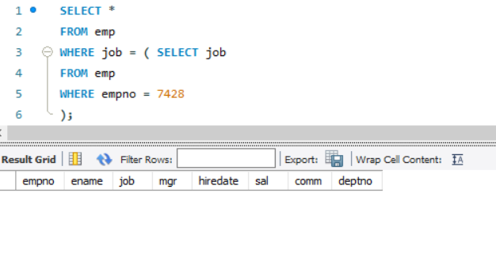**Display the employees whose job description is same as that of employee 7428.**

**TASK B**

**Display all employees who are working in the same department as that of employees who earn salary of 1250.** 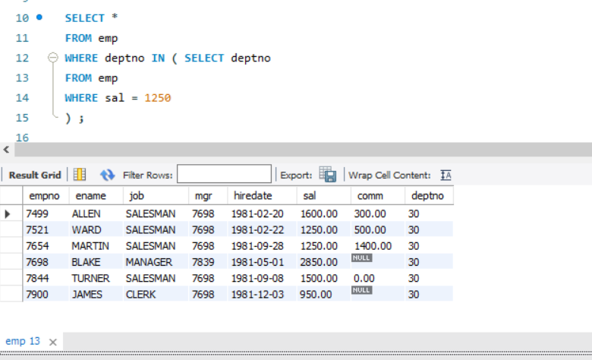

**TASK C**

* **Display the employ numbers and names of all employees who work in a department with any employee whose name contains an ‘A’.** 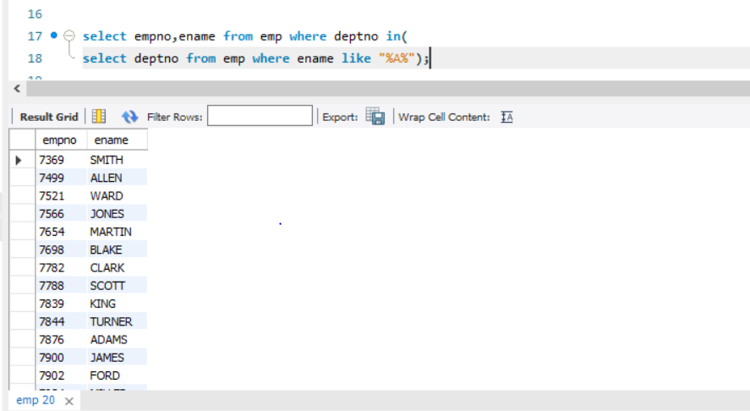
* **Display the minimum salary of employees who work in department 10 or 30.**

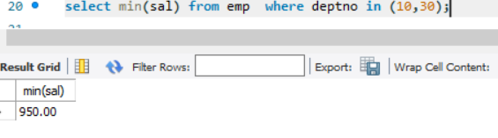 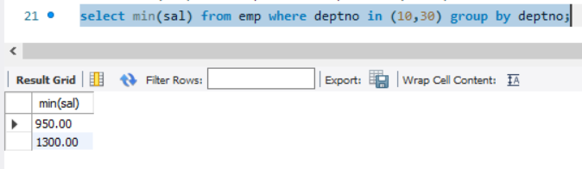

**TASK D**

**• Display all departments that have minimum salary greater than that of department 20.** 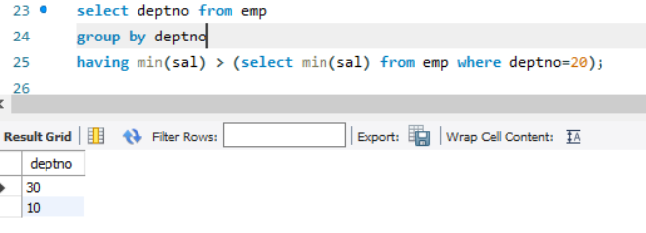

**• Find the employees who earn the same salary as the maximum salary of each department.** 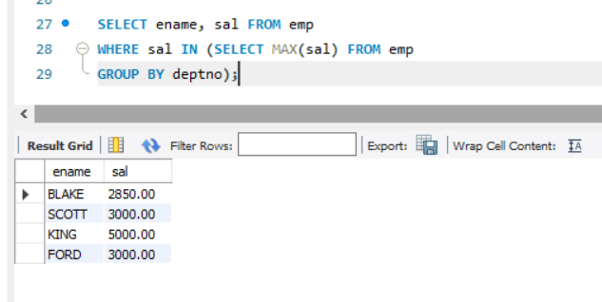

* **Display the name and salary of every employee who reports to KING.** 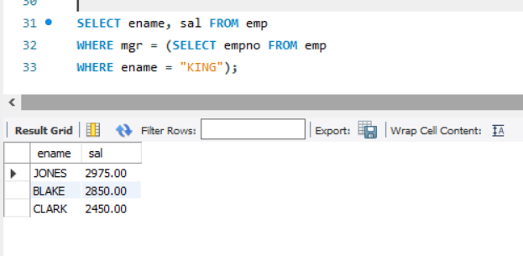
* **Find the details of highest paid employee.**

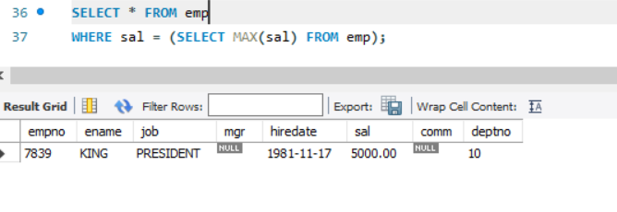

* **List the employees who are senior to the most recently hired employee working under KING.** 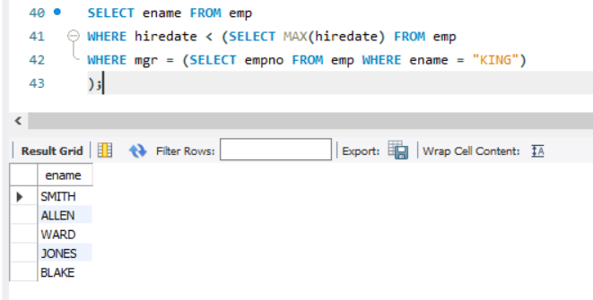
* **Display the annual salary of all the employees who salary is below that of all the employees employed in department 20 and department 30.**

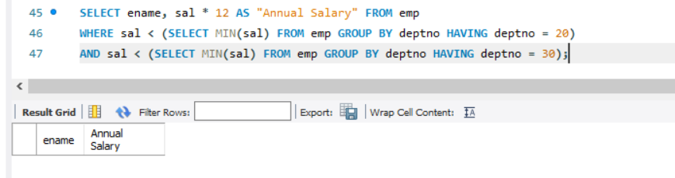

* **Display the names and salaries of all the employees who earn more than the least average salary of each department.**

